Pension DA:

1. In Transfer There is no edit form.
2. In new transfer Paid up to and letter date fields do not have calendar control.

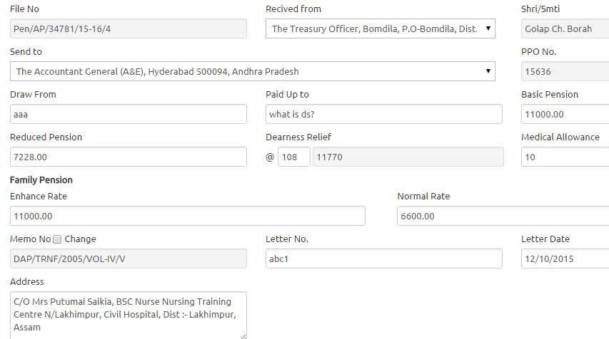

1. When clicked in Transfer -> Outside Case one file no is automatically loaded in

Search box.

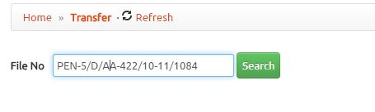

1. In Receipt files -> Pension File Allocate I think search function is not working.  
   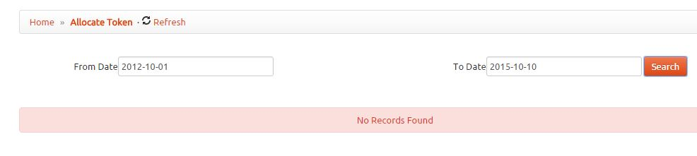
2. In Tracking -> Track files, need to put a clickable list with search option.
3. In Search File -> Search My file is returning repeated results.

